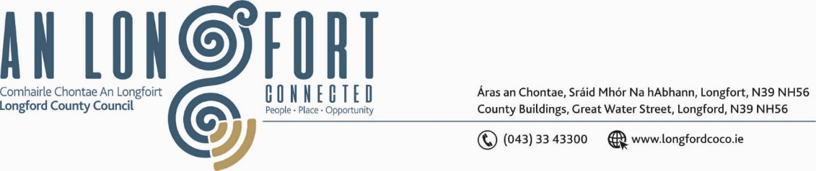

**GRANARD MUNICIPAL DISTRICT**

***Please note meeting will be held in Granard Library and via Microsoft Teams.***

**18 May 2022.**

**To: Each Member of Granard Municipal District.**

**Dear Member,**

You are requested to attend a Meeting of Granard Municipal District to be held in Granard Library and **via Microsoft Teams** on **Tuesday 24 May 2022 at 3.30pm** to transact business, as set out on the agenda hereunder.

**Yours sincerely**,

Ann Marie Mc Keon

______________________

**Ann Marie Mc Keon,**

**Meetings Administrator.**

**AGENDA**

Prayer before meeting.

**Presentation by Rath Mhuire & Dolmen Community Services Ltd**

**1.** Confirmation of Minutes as follows: -

* Granard Municipal District Meeting held on 22 March 2022 – copy enclosed.
* Granard Municipal District Committee Meeting held on 22 March 2022 – copy enclosed.

**2.** Matters arising from Minutes.

**3.** Declaration of Interest by Members.

**4.** Management Report incorporating Area Engineer’s Progress Report - enclosed.

**5.** Polling Scheme Review.

**6.** Community Grant Support Scheme 2022 – to follow.

**7.** Special Projects/Discretionary Funds 2022 – enclosed.

**8. Notices of Motions, submitted by Councillors, as listed hereunder –**

**Councillor Paraic Brady**

“I call on Longford County Council to contact Electric Skyline to up-grade the lighting in Drumlish village as the marquee is on again in August and there will be thousands of people attending this festival”.

**Councillor Turlough Mc Govern**

(i) “I call on Longford County Council to carry out essential repairs and maintenance to O’Hara’s building on Main Street Granard purchased since 2018 by Longford County Council”.

(ii) “I call on Longford County Council to install solar Driver feedback signs (DFS) for maximum effect on driver behaviour on the N55 approach into Granard town and on the R194 approach from Ballinalee into Granard town”.

(iii) “I’m calling on Longford County Council under the Rural Development funding to

conduct a visibility study of the derelict building on the former Matthews site with the

view to purchasing and developing the unit for an Exhibition/Gallery Centre with

Museum space to hold the collection of historical & Heritage items currently held in

Office and storage space. I believe it would be ideal due to the size of the

building and adequate space for parking around it.  Granard has been hailed as a

destination town and we believe this would be a positive step in the rejuvenation of a

derelict site, job creation and positivity for the key town in North Longford”.